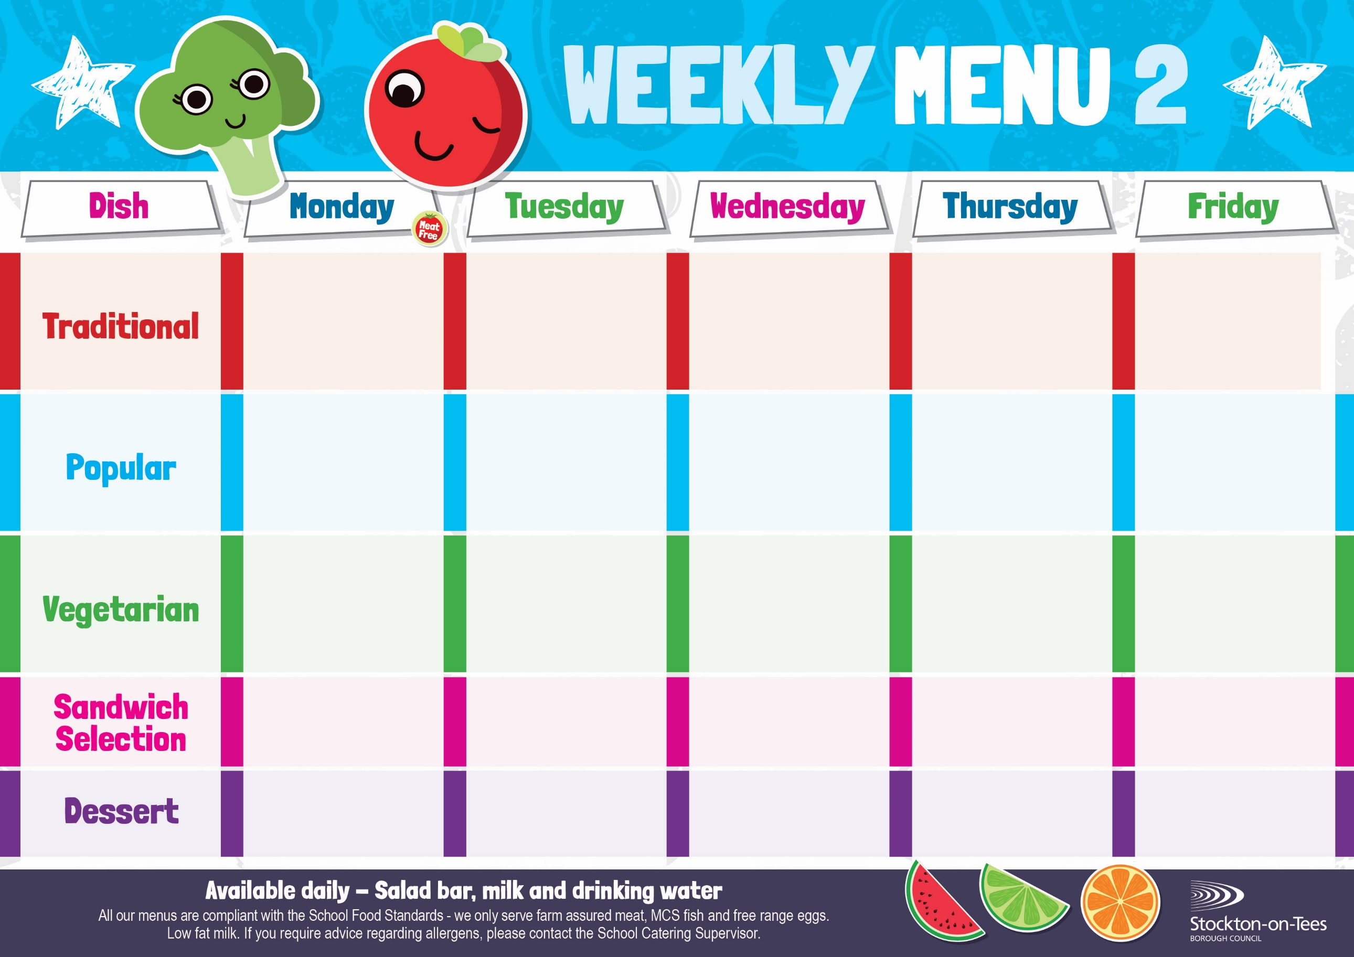

Marble Sponge &

Custard Sauce

Jelly

Homemade Biscuit &

Fresh Fruit

Creamy Rice Pudding & Jam Sauce

Ice Cream

Homemade Biscuit &

Fresh Fruit

Chocolate Crunch & Custard Sauce

Raspberry Bun

Homemade Biscuit &

Fresh Fruit

Vanilla Sponge &

Custard Sauce

Choc Chip Cookie

Homemade Biscuit &

Fresh Fruit

**Weeks beginning 13th January, 3rd February, 3rd & 24th March, 2025**

Cheese Omelette

Oven Baked Chips

Garden Peas

Baked Beans

Fish Goujons

Oven Baked Chips

Garden Peas

Baked Beans

Quorn Toad in the Hole

Creamed Potatoes

Broccoli

Diced Carrots

Corned Beef Pie

Creamed Potatoes

Broccoli

Diced Carrots

Sausage Roll

Potato Wedges

Baked Beans

Spaghetti Bolognaise

Homemade Garlic Bread

Mixed Vegetables

Apple Pie &

Custard Sauce

Decorated Iced Sponge

Homemade Biscuit &

Fresh Fruit

Quorn Mince & Dumplings

Creamed Potatoes

Green Beans & Swede

Fish Star

Baked Jacket Potato

Spaghetti Hoops

Egg Mayonnaise

Oven Baked Chips

Roast Ham

Baked Jacket Potato

Tuna Mayonnaise

Potato Wedges

Quorn Bolognaise

Homemade Garlic Bread

Mixed Vegetables

Cheese

Baked Jacket Potato

App

Egg Mayonnaise

Roasted Potatoes

Tomato Pasta Bake

Homemade Herby Bread

Garden Peas

Homemade Pizza

Roasted Potatoes

Garden Peas

Spaghetti Hoops

Toad in The Hole

Creamed Potatoes

Broccoli

Diced Carrots

Mince & Dumplings

Creamed Potatoes

Green Beans

Swede