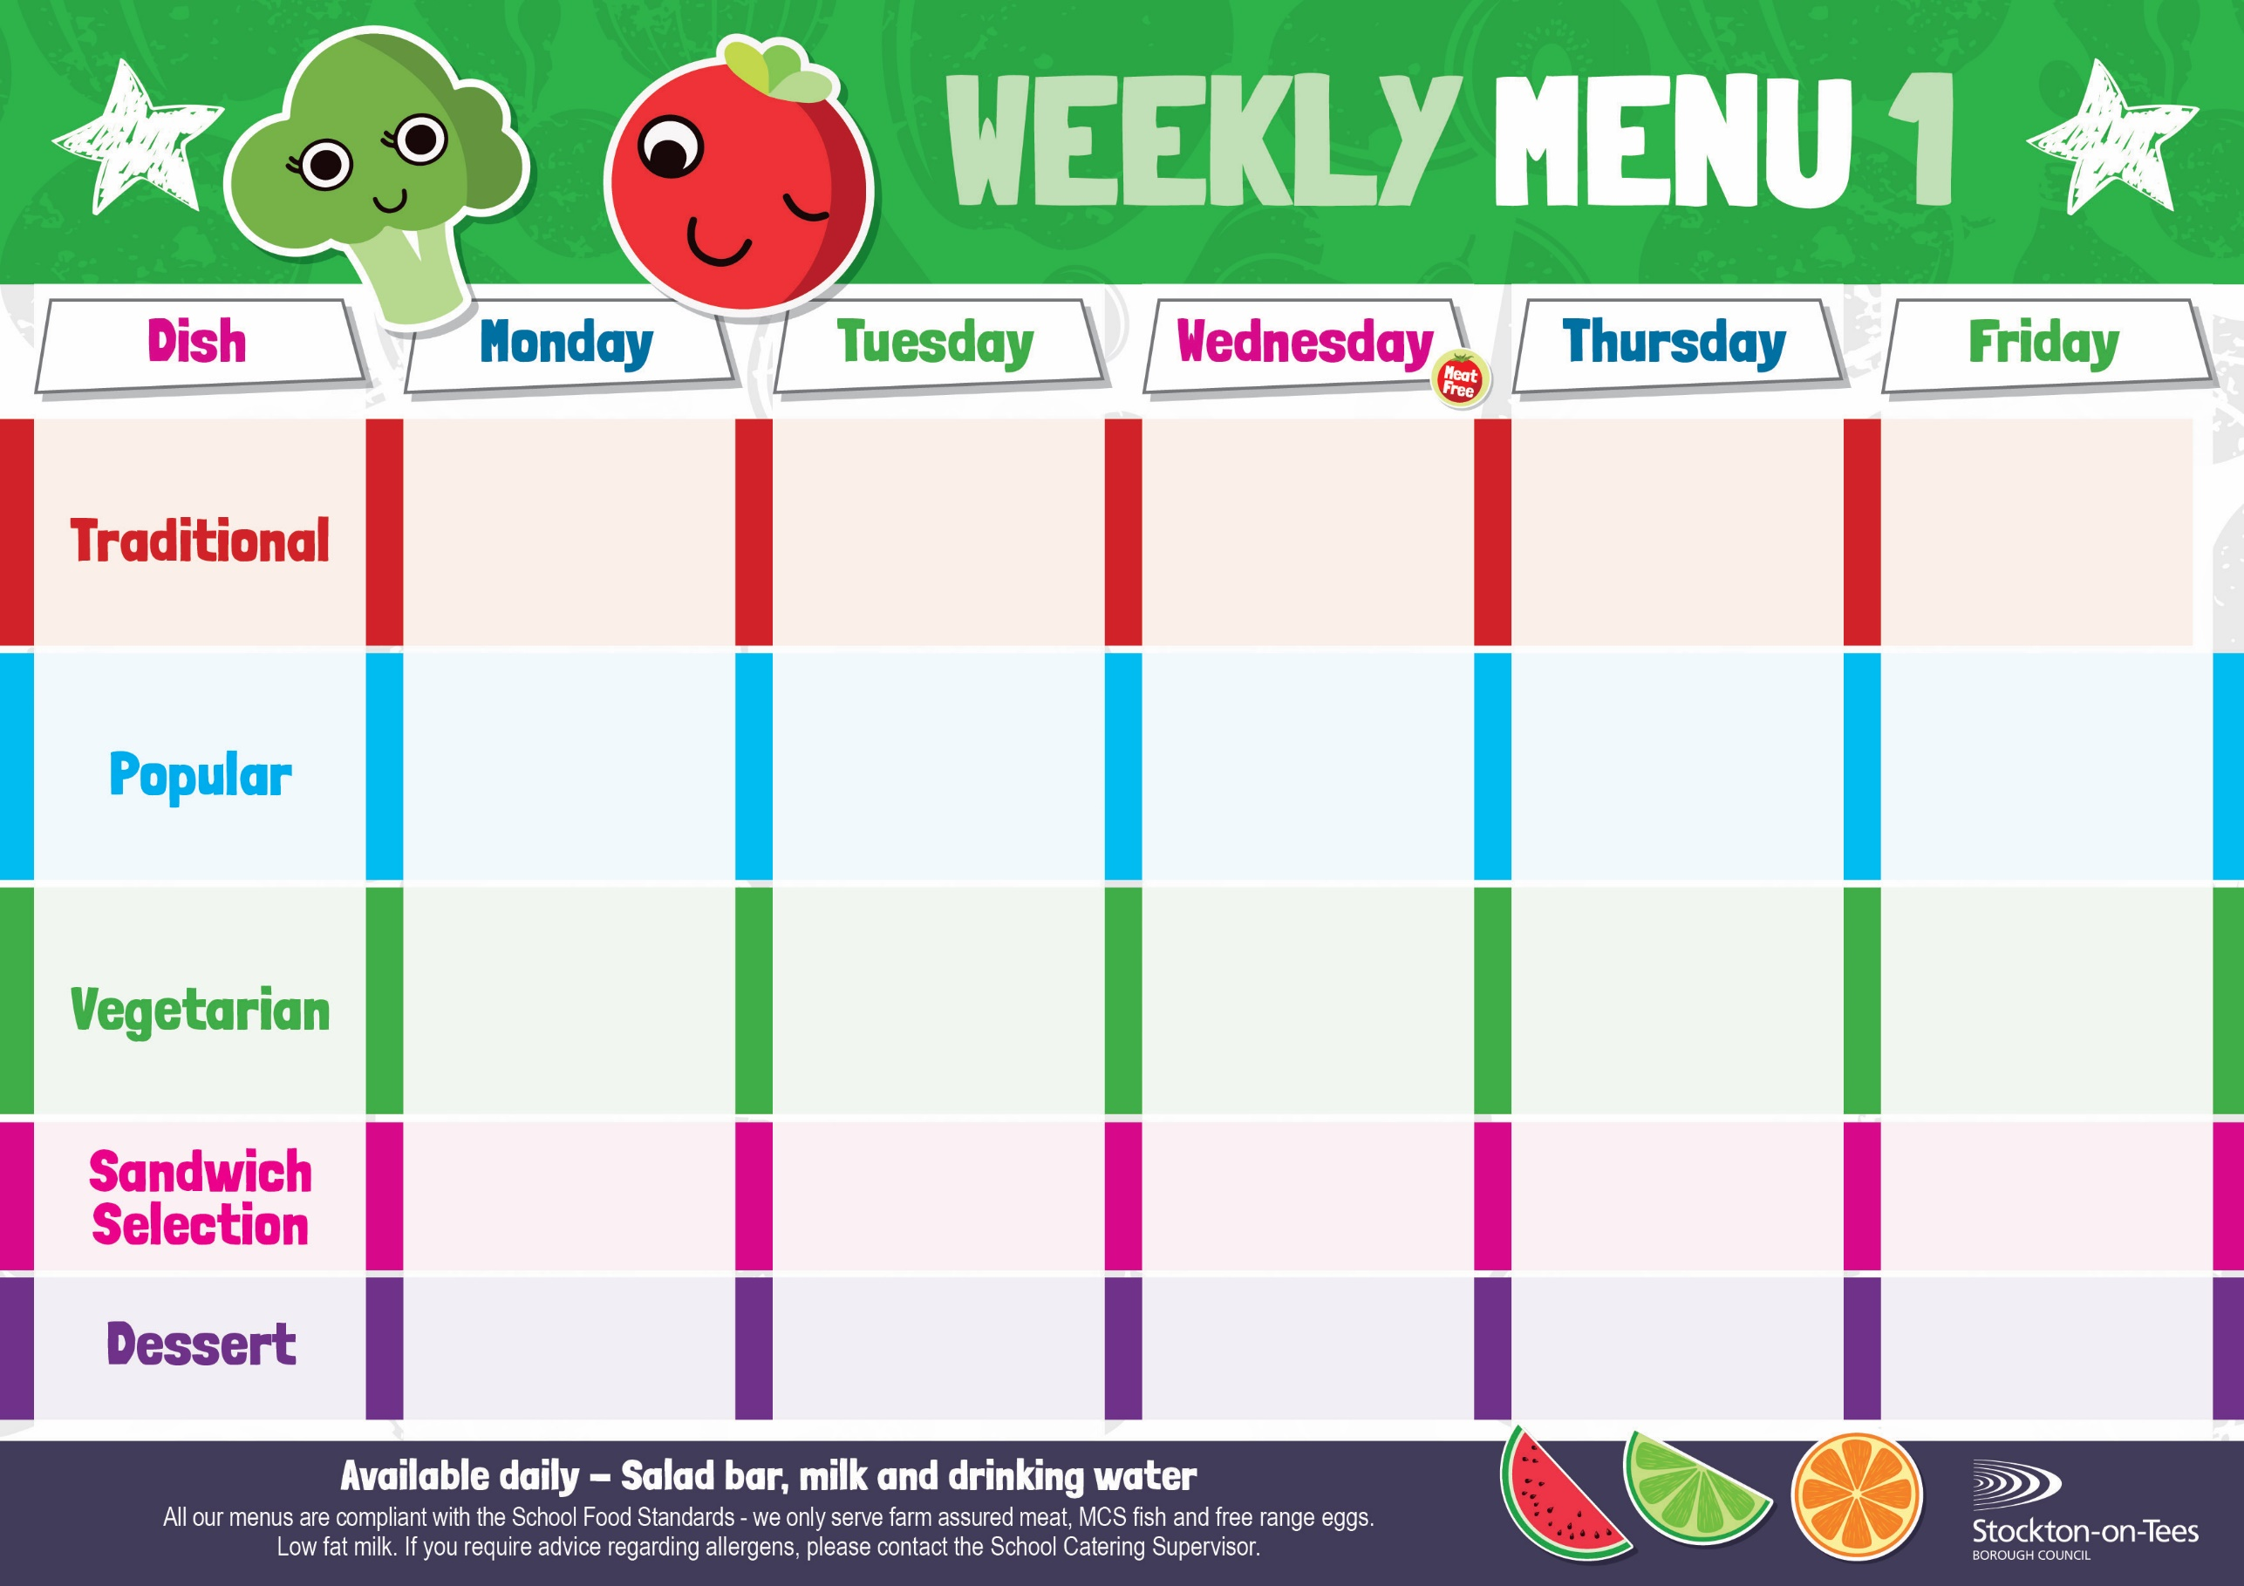

Baked Sausages

Potato Wedges

Spaghetti Hoops

Egg Mayonnaise

Roasted Potatoes

**Weeks beginning 6th & 27th January, 17th February, 17th March & 7th April, 2025**

Creamy Rice Pudding &

Jam Sauce

Ice Cream

Homemade Biscuit &

Fresh Fruit

Syrup Roly Poly &

Custard Sauce

Iced Bun

Homemade Biscuit &

Fresh Fruit

Oaty Apple Crumble & Custard Sauce

Cup Cake

Homemade Biscuit &

Fresh Fruit

Cornflake Tart & Custard Sauce

Fruity Muffin

Homemade Biscuit &

Fresh Fruit

Chocolate Sponge & Custard Sauce

Jelly Whirl

Homemade Biscuit &

Fresh Fruit

Egg Mayonnaise

Oven Baked Chips

Cheese & Onion Roll Oven Baked Chips

Baked Beans

Baked Jacket Potato with Tuna

Cheese

Baked Jacket Potato

Fish Fillet Fingers

Baked Jacket Potatoes

Spaghetti Hoops

Harry Ramsden

Fish Fillet

Oven Baked Chips

Mushy Peas &

Baked Beans

Tuna Mayonnaise

Potato Wedges

Baked Quorn Sausages

Potato Wedges

Spaghetti Hoops

Quorn Vegan Dippers

Roasted Potatoes

Baked Beans

Sweetcorn

Roast Ham

Baked Jacket Potato

Baked Jacket Potato with Cheese or Baked Beans

Vegan Meatballs

in Tomato Sauce with Pasta

Mixed Vegetables

Pork & Carrot Meatballs in Tomato Sauce with Pasta

Mixed Vegetables

Roast Turkey with Sage & Onion Stuffing

Creamed Potatoes

Cauliflower & Swede

Homemade Pizza

Roasted Potatoes

Baked Beans

Sweetcorn

Minced Beef Pie

Creamed Potatoes

Carrots

Broccoli